Mediterranean Sea Community of Common Interest
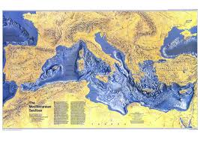The Mediterranean Basin
Generalities
Unfortunately, the EBA representatives of Countries facing the Mediterranean Basin, despite their commitments evidenced In Berlin ‘15 during the launch of the CCI, haven’t shown a particular interest in furthering the issue, certainly due to other incumbent needs or personal impossibilities.
This situation hasn’t allowed a fruitful exchange of views, nor has permitted to collect data referred to the different national sites, so as to gather in a unique, general “window”, all the elements of knowledge related to the various locations and the various approaches in tackling the same issues, with the aim of considering possible agreed ways in progressing the matter.
As consequence, no sensitive developments have been so far registered in this regard, but as the principle of dealing with areas of common interest is still valid, in agreement with the Presidency this topic is submitted again, with the hope this time it could result more appealing and productive of significant outcomes.
Now, apart from the topics already submitted to the Group’s attention, which are still pending and to be resumed during the Palma Assembly, my intentions are to

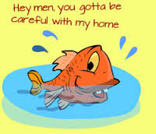
focus on issues which are more related to the boaters activities, in order to enhance their sound behavior towards the marine environment.

Background
None could dispute that the Mediterranean represents a system of particular relevance: best known for its landscapes and holiday images of sparkling blue sea and Sun, the Mediterranean is a complex and unique environment designated by MARPOL as a Special Environmental Area and as such requiring special approach.
It has different natural geophysical features, which have their own characteristics and way of interacting. Though it contains only 1% of the Earth’s ocean water, the Mediterranean Sea hosts 8 % of the world’s biodiversity. 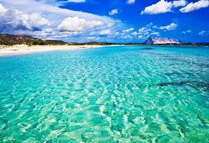
Sardinia crystal waters
But those biological treasures are now under threat from human pressures, embracing unregulated tourism, oil-drilling platforms and maritime traffic, inclusive of recreational craft sailing its waters due to more manageable weather conditions.

Overview and some statistical data
Actually the number of boats at sea and at berth along the Mediterranean coast reaches a magnitude of approximately 2.0 million boats.
Boating infrastructures
On a worldwide level, Europe has the most marinas although the boat fleet is smaller than in other regions of the world. In the Mediterranean in particular, a study found over 1000 marinas in activity (up 6% from 890 marinas recorded in 2008) including 860 in Southern Europe and 140) on the coasts of North African Mediterranean countries, the Middle East and Turkey
Services in Mediterranean marinas
Their availability shows an increase in restaurants in Spain, France, Italy and Greece; an increase in WIFI service in France, Italy, Greece and Turkey; unfortunately no change in sewage and ballast water collection services.
Dry storage facilities:
It’s a carefully growing phenomenon in the Mediterranean. In terms of impacts, the efficient organization of dry storage facilities reduces boat maintenance costs and the amount of antifouling paint (boats require treatment less often).
Environmental impacts - Sea waste.
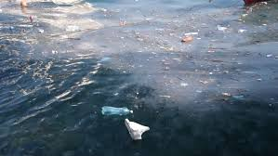
It’s estimated that there are 700 million tons of waste littering the seas floors and surface. As the largest concentrations are in the Mediterranean and the refuse can accumulate up to 2,000 meters deep, it’s time also for boaters to launch a warning on the issue and contribute to halt/mitigate this bad habit.
To be frank, none could reasonably say that boat users are the main sea polluters, nevertheless it’s our task, as Association, to keep constantly alive and widespread towards the new generations the focus on eco-friendly approaches related to the sound use of natural resources in general, and the marine in particular.
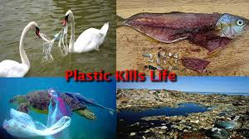
Actually, areas where recreational boating is developed suffer from significant pollution tied mainly to port activities (dredging, fuel distribution, sewage), boats (paint, sewage, bilge pumps, engines), boaters and infrastructures (wastewater treatment plants, urban activities). Pollution is mainly organic, bacterial and chemical and is added to plastic waste, packaging and food waste that surpass limits supported by ecosystems during peak seasons.
Spurred on by these findings, some marinas and local governments are taking initiatives that focus on prevention. These include waste collection services with boats moored off the busiest ports and bays, as well as the distribution of guidebooks on eco-friendly behaviors. On average, recreational boats (average of 3.5 people) produce 2 kg of waste per day, with water consumption depending on the type and size of boats (for super yachts the order of magnitude is similar to cruises).
Inoperable pleasure boats are a source of various types of waste25, some of which can be hazardous (oils, batteries etc.).

Proposal for eco-friendly actions for recreational boaters
At sea
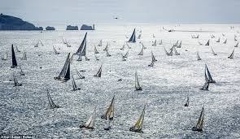
• Be careful of light objects that the wind could blow overboard (plastic bottles and glasses);
• Use ashtrays; butts take a long time to decompose and can be swallowed by birds and fish;
• Avoid washing dishes aboard and if so, wash with freshwater without soap;
• Avoid using toilets at sea, especially near shores or swimming areas, equip watercraft with black water holding tanks;
• Choose biodegradable products to clean lavatories.

Waste
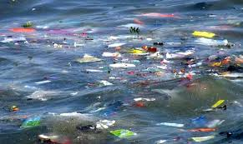
• Do not throw any litter overboard and pick up plastic bags floating in the water; separate organic materials and packaging to be recycled and designate a place for storing it out of the wind;
• In the harbor, throw waste in designated bins, comply with recycling instructions and encourage others to do the same;
• Only empty waste water tanks in designated places.

In the harbor
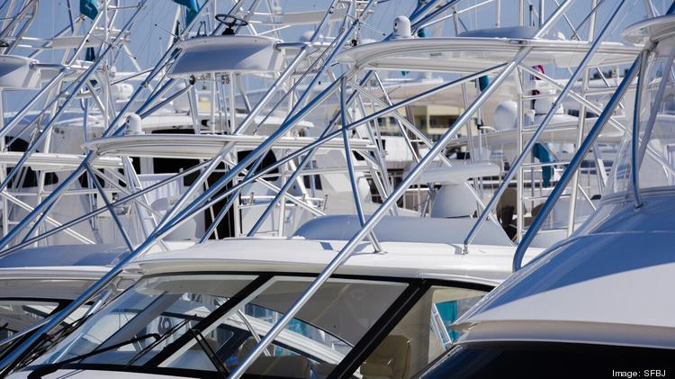
•Control water consumption through the use of aerators on faucets and toilet tank water savers to make considerable water savings;
• Consider installing a rainwater collection system to be used to rinse equipment or wash boats (water purifiers can be used to purify recycled sea and rainwater.

Boat maintenance
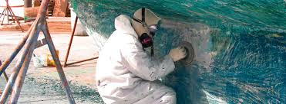
• Use an LPG, electric or four-stroke engine rather than a two-stroke engine; maintain the engine with eco-friendly lubricants and have it serviced every year; • Be careful when filling Jerri cans: use a manual pump and a funnel that is large enough to avoid spilling fuel in the harbor water; favor mechanical cleaning of boat hulls. Because anti-fouling paint is harmful to marine flora, use a paint containing the least amount of lead and pesticides possible and apply it carefully;
• For small watercraft, only paint the useful surface, up to the floatation line;
• Carry out careening in areas of the marina set up to recover and treat residue and runoff water.
Even more • Participate in a nautical sport that does not consume fuel (sailing, kayaking, windsurfing); lower your speed near shore as waves can cause shore erosion and disturb fauna;
• Use environmentally safe products: No biocides, phosphate detergents or toxic wax.
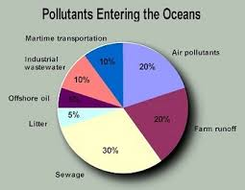
REMEMBER !!!!
Conclusions
As Boaters and marine habitat users, we can’t but put in place all the possible efforts to protect our sea environment. To this aim we must strive the desire to:
- make the Mediterranean a site for our sailing experiences, but also a forum for reflection, dialogue, proposed actions, open and of mutually beneficial exchange, in this convinced that the development of marine activities and a sound cultural approach are vehicles for economic rise and more options for boaters;
- the development of waterways and roads in the Mediterranean / cruises, coastal sailing, ports of call, stopovers… along Mediterranean towns, cities and sites;
- the implementation of a tourist portal for the Mediterranean, a single gateway to a wide range of information, tourist products, services, reservations, sales that stimulates the sharing of experience between public and private players;
- the development of excellent offers and services for the marine and cultural tourism;
- the integration of safety issues in developing marine activities in order to better preserve human lives and prevent pollution risks in the Mediterranean,
- influence a concerted policy and create a sustainable development network for nautical activities within the framework of the agreements and principles of the Barcelona Convention and similar treaties;
- the creation of a joint quality and sustainable marinas development model, with a collective benchmarking brand (Clean Ports, environmental awareness, heritage, hospitality, service quality, etc.);
- use of the growing marine and cruise-based tourism industries as an important gateway to Mediterranean countries and foreign boaters sailing its waters;
Final remarks:
In absence of alternative inputs, I’ve tried to stress the potential and shared lines of actions which could be taken by boaters in order to make a sound use of the Mediterranean waters, with the aim of exploiting its beauties and values, preserving at the same time the integrity of its ecosystem.
My hope is that these notes could trigger a more dynamic debate during the Friday 15 April pm meeting, where your comments or observations will be extremely appreciated.
Looking forward to seeing you soon, receive my best regards.
Giancarlo OLIMBO
olimbog@gmail.com

